PEACEFUL BAY PROGRESS ASSOCIATION INC  Peaceful Bay WA 6333  ABN: 54389092839 www.peacefulbayprogress.org.au  Committee Meeting Minutes  for Sunday 3 January, 2021 | 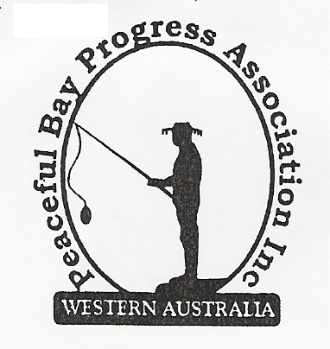

Meeting Opened: 9.05am

Present: Hayden Jones (President) Reg Radford (Vice President) Katie Eddington (Treasurer) Mavis Jones (Secretary) Graeme Liddelow, Leanne Taylor, Lorraine McNamara
Community member Lisa Jones

Apologies: Janine Phillips, Tony Armstrong

1. Confirmation of Minutes from previous meeting 6 December, 2020

Moved: Mavis Jones 2nd – Accepted and carried by all.

2. Business Arising: All items covered in general business.

3. Correspondence:
IN:
8 Dec – email from Claire Thompson acknowledging invitation to PBPA events
8 Dec – email from NRRA re notice of AGM and attachments
9 Dec – email from NRRA re Agenda for AGM + minutes of previous AGM
9 Dec – email from Claire Thompson Agenda for Council Meeting on Website.
11 Dec – email from Peter Hennig, Dept of Primary Industries and Regional Development re
rabbits control plus information attachments.
21 Dec – email from Claire SoD – Staggered Leases for Peaceful Bay Leaseholders
21 Dec – email from Claire Thompson Minutes of 15 December meeting on Website.

OUT:
7 Dec – email letter to the Shire of Denmark to request an update on progress of staggered
lease proposal.
7 Dec - email letter to Shire of Denmark re access track to dog exercise area drop off again
needing attention.

Moved: Hayden Jones 2nd Graeme Liddelow - Accepted/Endorsed.

4. Finance Report:
A verbal report was tabled and all proceeding to budget. The annual Hall maintenance
funding has been received from the Shire of Denmark.

Moved: Katie Eddington 2nd Hayden Jones - Accepted/Endorsed.

5. Maintenance Report:
Steps to the beach has one broken and one loose step. Graeme advised this has been
reported and Katie will follow up with a phone call.

The bike jump constructed by kids near the Tank on First/East Ave junction needs closing
down as it is undermining the base and is a safety issue as kids are riding towards it from the
car park near the shop and narrowly missing pedestrians.

The old BBQs at the hall will be demolished, the area landscaped and the ground levelled
to accommodate seating for community events.

Extra rubbish bins. The PBPA owned bins need to be located as it is unsure where they are.
They will then be marked as our bins so they can be identified if they go missing in future.
6. General Business:

Christmas Party and New Year Fun Day. Both events were well supported and numbers
were up on last year. The Fun Day definitely needs more volunteers to spread the load. A
running sheet, “How To” sheets and organisational lists will be prepared from this year’s
experiences. The earlier start time to Fun Day proved popular and may have increased
participation.
Feedback from community members was positive for the Christmas Party and the Fun
Day and they appreciated the effort the Progress and volunteers put in to organising both
events.

Thank you to Graeme for undertaking the role of Father Christmas and thank you to Callum for
providing the Blue Esky and generously donating it to the Association.
We agreed to look into getting another esky.

The PBPA will write “Thank You” letters to the Fire Brigade (Trevor Brown and crew) for
providing and manning the fire engine for kid’s rides at the Christmas Party and to the Caravan
Park Shop for donating the ice and lollies for the Christmas Party and the Fun Day.

Welcome to new committee members. Lorraine McNamara was welcomed as a new
Committee member. Welcome to Reg as Vice President. Thanks to retiring committee
members Gill Irvine and Callum Baxter. Janine verbally confirmed her acceptance of
Committee Nomination to Secretary Mavis Jones.

Committee Meeting Dates. The following dates were set for the monthly committee
meetings. Every first Sunday except for April which is on Easter Monday and September which
is on the second Sunday due to Fathers Day being on the first Sunday.

Sunday – 7 February Sunday – 7 March Monday – 5 April
Sunday – 2 May Sunday – 6 June Sunday – 4 July
Sunday – 1 August Sunday – 12 September Sunday – 3 October
Sunday – 7 November Sunday – 5 December

The PBPA AGM was held with 20 members in attendance.

7. Other Business:

8. Meeting closed: 10.35 am Next Meeting: SUNDAY 7th February, 2021

