PEACEFUL BAY PROGRESS ASSOCIATION INC  Peaceful Bay WA 6333  ABN: 54389092839 www.peacefulbayprogress.org.au  Committee Meeting Minutes  for Sunday 2 May, 2021 | 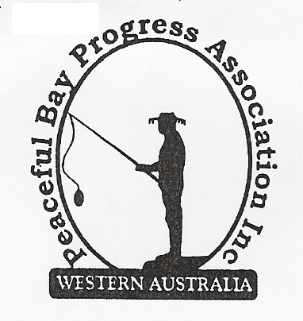

Meeting Opened: 9.00 am

Present: Hayden Jones (President), Reg Radford (Vice President), Katie Eddington (Treasurer), Lorraine McNamara, Janine Phillips,

Apologies: Mavis Jones, Graeme Liddelow, Leanne Taylor, Tony Armstrong

1. Confirmation of Minutes from previous meeting 4 April, 2021

Moved: Lorraine McNamara 2nd Reg Radford – Accepted and carried by all.

2. Business Arising: All items covered in general business.

3. Correspondence:
IN:
07 Apr – email from Ryan Harding re Synergy account
07 Apr – email from Claire Thompson re question from Ward Meeting re Development Amounts
09 Apr – email from Callum Baxter re Hosting Renewal is paid - attached Invoice for our records.
14 Apr – email from Microsoft re Services Agreement updates.

OUT:
06 Apr – emailed letter to David King re Public Toilet building maintenance.
06 Apr – Works order raised for Ladies’ Toilet at Oval – leaking pipe under hand basin.
06 Apr – Mavis emailed Shaun and Sally O’Rourke confirmation of new email address.
06 Apr – Hayden replied by phone to Eva Overton re Containers for Change Scheme.
07 Apr – Hayden replied by phone to Ryan Harding re Synergy account for Playground and Oval.
08 Apr – Emailed minutes of meeting 4 April to Committee members

Moved: Katie Eddington 2nd Lorraine McNamara - Accepted/Endorsed.

4. Finance Report:
All proceeding to budget.
Moved: Katie Eddington 2nd Hayden Jones - Accepted/Endorsed.

5. Maintenance Report:
It was suggested we contact the Shire re Beach Access steps – Flag Hill access –
Beach steps at Sea Rescue access, to confirm they are still budget items.

Hayden to follow up Hall work and draw up a sketch of proposed landscaping.

Reg raised the idea that we look at obtaining extra playground equipment such as a climbing
frame as an alternative for kids to discourage climbing on the shade sails.

6. General Business:
Janine to follow up what constitutes a trigger for building approval to allow individual
leaseholders to negotiate a new lease term.

7. Other Business: Reg Radford will be an apology for June meeting.

8. Meeting closed: 10.00 am Next Meeting: SUNDAY 6th June, 2021

